**Overhead Management through Template**

## Introduction:

Overhead management is an important topic in product costing. It helps to distribute indirect product cost to the product. SAP provides few standard means of charging overhead cost to the product, like Costing sheet, allocation cycles, and Overhead template. In this document we will see the extensive usage of overhead template, the configuration required, master data maintenance and the overhead cost allocation.

**Overhead template:**

Overhead template is a method of applying overheads to finished goods, semi-finished goods, materials on the basis of template. Overhead template provide more freedom to apply overheads rate from traditional methods of overhead rate as used fixed percentage on raw material or fixed percentage on labour cost through costing sheet.  It provide alternative to calculate overhead based on complex formula. For example, if we want to apply overhead rate based on net quantity produced, then we can apply overhead templates. We will see this in more detail in the document.

**Configuration required:**

**Define Overhead key:**

1. IMG –> Controlling –> Prod Cost Controlling –> Product Cost Planning –> Basic Settings for Material Costing –> Overhead –> Define Overhead Keys

Overhead key is a four digit alphanumerical key, which is assigned to process/production order. That link actual overhead template cost to the orders. (e.g. OH01 as Overhead key)

[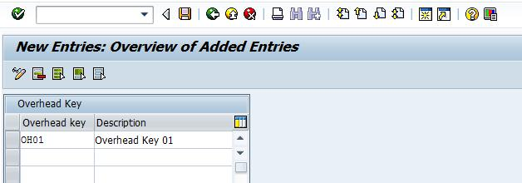](https://blogs.sap.com/wp-content/uploads/2014/08/1_530648.jpg)

**Define** **Overhead group**

1. IMG –> Controlling –> Prod Cost Controlling –> Product Cost Planning –> Basic Settings for Material Costing –> Overhead –> Define Overhead Group

Here we define the overhead group, and assigned to valuation area and overhead key. Overhead group maintained in material master data in Costing view 1 tab.

[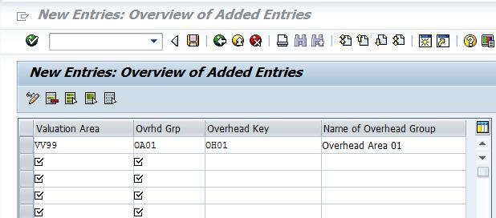](https://blogs.sap.com/wp-content/uploads/2014/08/2_530637.jpg)

**Define Costing Sheet**

1. IMG –> Controlling –> Prod Cost Controlling –> Product Cost Planning –> Basic Settings for Material Costing –> Overhead –> Define Costing Sheets

If we are using overhead template then also we need to create a costing sheet but no rules need to define for overhead calculation in costing sheet. Here we just need a costing sheet with no credit, no base, etc. The purpose of creating a costing sheet name, so that we can assign overhead groups, template to costing sheet and then assign costing sheet to costing variant and this link takes the cost from overhead template while doing the cost estimate.

[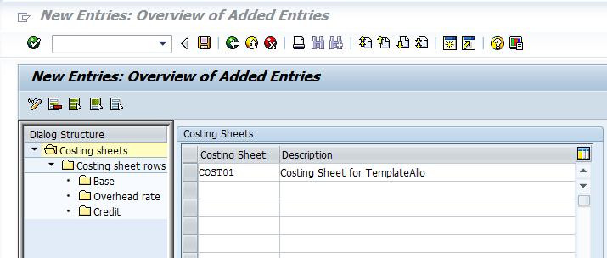](https://blogs.sap.com/wp-content/uploads/2014/08/3_530638.jpg)

**Create Overhead template**

Transaction CPT1:

There are two different types of overhead templates that need to be created, one for Plan overhead (in environment 001) and another for actual overhead (in environment 009).

Creating plan overhead template: define the name of overhead template and environment as 001

[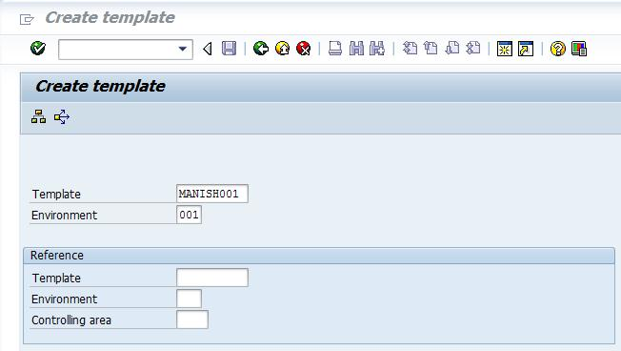](https://blogs.sap.com/wp-content/uploads/2014/08/4_530651.jpg)

Enter

In template Overview,

➢ Type: select Calculation row for cost centre & activity combination

➢ Object: Define COSTCENTER/ACTIVITY e.g. 1000000001/MMM

➢ Plan Quantity: define plan quantity with formula available. Here I have provided a quantity which will be equals to **“Cell ((OderTotalQuantity – OrderTotalScrapQuantity)/ CostingLotSize))”**  It means the system will take roundup value to the next highest whole number for a quantity from ration of Net Quantity produced to Costing lot size.

➢ Plan Activation: Activate

➢ Actual Activation: No as it’s for environment 001 i.e. for plan only

[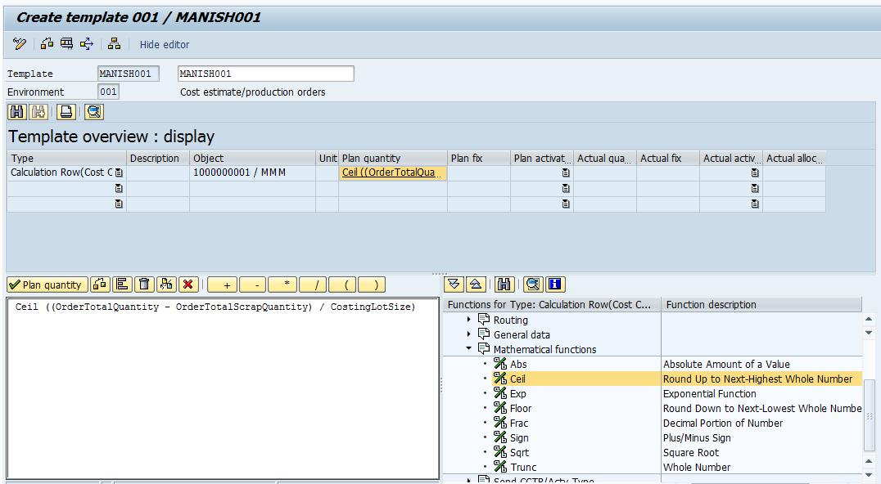](https://blogs.sap.com/wp-content/uploads/2014/08/5_530652.jpg)

This is just a hypothetical example that I have given, but we can chose the different options available from standard and apply mathematical formulas if required.

The standard options are given below

[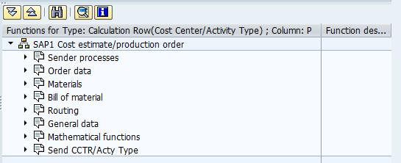](https://blogs.sap.com/wp-content/uploads/2014/08/6_530653.jpg)

If there will be any error then system will give an error message. Now check where it’s marked as red, and then rectify that part.

For example

[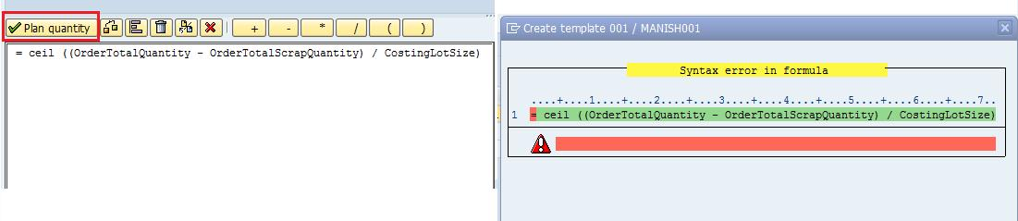](https://blogs.sap.com/wp-content/uploads/2014/08/7_530654.jpg)

**Assign overhead template to costing sheet & overhead key**

After defining the overhead template, these plan and actual overhead templates need to be assigned to costing sheet and overhead keys.

Transaction KTPF

[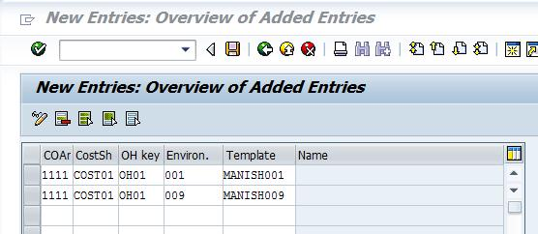](https://blogs.sap.com/wp-content/uploads/2014/08/8_530655.jpg)

After this all the configuration are ready, but few points need to be taken care:

➢ Overhead group need to be assigned in costing 1 view of material master data.

➢ Overhead key need to be assigned in process/ production orders

➢ Standard cost estimate automatically determine overhead template cost

➢ For actual overhead cost, we need to execute CPTD for overhead allocation at plant level and CPTA for overhead allocation for single order level.

**Conclusion**

In SAP there are different ways of applying overhead cost for product costing, but which one to choose is depend upon the requirement. Here I have tried to explain the usage of Overhead template and what are the configurations required for the same.

Templates are nothing but a tool for complex calculation of formulas.

Templates can be used for formula planning, activity allocation or overhead cost allocation. Environment of template tells you what you want to do with a template.

If you want OH Calculation to product instead of a Costing Sheet.. use environment "1" for Plan and "9" for actual.

You have lot of pre-defined SAP complex formulas available in the templates which you can use..

Template Creation

Environment varies with requirement and config will also vary , considering you are using templates with environment 1 and 9 ( for Cost Allocation to Product )

Transaction CPT1 :-

1. Enter the name of the template and environment 001 2. Inside the template Type = Cost Centre / Activity Type

3. Description = as you please

4. Object =   Use  the sender object .. either cost enter or combination of CC and AA whatever you need :

SenderCostCenter = 'XXXXXX' AND

SenderActivityType = 'AAAA'

or you can use the screen in bottom right to input the formula

5. Plan Quantity =  Use the screen bottom for formula or use your own one ..

BomItemAlternativeQuantity( AlternativeQuantityUnit =

MaterialBaseQuantityUnit, ConditionField = BomItemComponents,

ComparisonValue = 'XXXXXX' )

6. Plan Activation = ACTIVE

7. Actual Quantity =  Use your own formula using predefined SAP formulas

OrderMaterialQuantityConf( Material = 'XXXXX' )

6. Actual Activation = ACTIVE

Assignment of the Template

1. Create a OH Key using SPRO > Controlling > Prod Cost Controlling > Product Cost Planing > Basic Settings for Material Costing > Overhead > Define OH Keys

2. In Transaction OKZ2 Create OH group and assign that to the OH Key created in 1

3. Create Cost Sheet (only code and name) in SPRO > Controlling > Prod Cost Controlling > Product Cost Planing > Basic Settings for Material Costing > Overhead > Define Costing Sheets

4. In Transaction KTPF assign Controlling Area : Costing Sheet : OH Key : Template Environment : Template

5. In material master costing 1 view assign the OH group to the material (standard cost estimate reads this)

6. In the master data of the order assign the costing sheets and OH key etc so that the actual template allocation can happen.

Execution

Plan template is not required to be executed. At the time when you run CK11N or CK40N it is taken care of.

Actual Template allocation can be done with transaction CPTA - Individual Processing and CPTD - Collective Processing

I hope you would find this useful and you can further explore templates for the various formulae that you can define using th bottom right hand side in the screen of CPT1 to create magic in allocation. What I told here is very basic.

### Template Allocation in Actual

The use of template allocations is one method to assign overhead costs. This method is unique for several reasons:

* Costs are not just allocated, but the system also determines the quantities that the respective receiver objects consume or utilize; costs are calculated based on the quantities and prices, and therefore more accurately determined
* Working with templates: the sender, quantities and activation time do not already exist, but can be dynamically determined through the template at the time of the calculation
* The template uses functions defined by the user or already provided in the system to determine the needed data; these functions pull information already in fields or carry out complex algorithms from the operative data in the SAP system; they are created and maintained in the environment maintenance
* Sender objects can be business processes or cost centres/activity types. Possible receiver objects of the template allocation in actual can be:
  + Product Cost Collector
  + PP-Production Orders
  + CO-Production Orders
  + PP-Process Orders
  + Sales Orders
  + Service Orders
  + Internal Orders
  + WBS Elements
  + Header and activity assigned network
  + Profitability segment of profit and market segment analysis
  + Cost centers or cost centers/activity types
  + Business Processes

In order to describe the allocation quantities in actual, you can draw upon actual quantities updated in the SAP System (such as the Logistic Information System or the confirmed quantities entered in the system).

Example Example

For example, the number of purchase orders per sales orders serves as the process driver of the procurement process for a sales order processor. You can configure the Logistics Information System so that it updates the appropriate key figure for this sales order for each procurement transaction related to the order. Thus, at the time of template allocation, the relevant template function uses the most recent information on procurement occurrences for the sales order from the Logistics Information System

Template-Allocation for Cost Objects (example, production order)

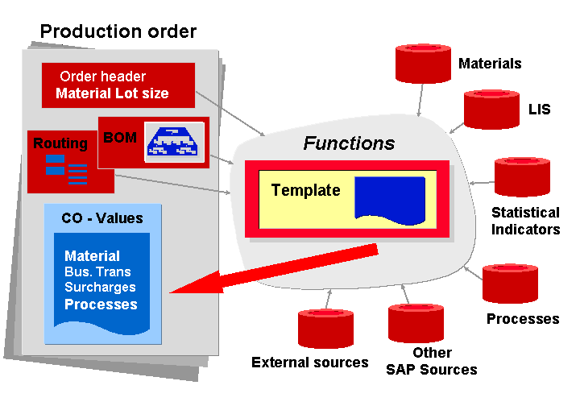

#### Prerequisites

These include:

* Creating the necessary sender objects; for example [Business Processes](https://help.sap.com/doc/2e11d553088f4308e10000000a174cb4/2.6/en-US/frameset.htm?757ab853ff98b44ce10000000a174cb4.html) or Cost Center/Activity Types
* Maintaining the [environment](https://help.sap.com/doc/2e11d553088f4308e10000000a174cb4/2.6/en-US/b31ed553088f4308e10000000a174cb4.html) or functions necessary for your receiver object
* Providing the process drivers (for example, statistical key figures) used by the functions
* Creating appropriate [templates](https://help.sap.com/doc/2e11d553088f4308e10000000a174cb4/2.6/en-US/0986d45398184308e10000000a174cb4.html)
* Assigning the template to the receiver object ([Cost Driver](https://help.sap.com/doc/2e11d553088f4308e10000000a174cb4/2.6/en-US/frameset.htm?dfb64c53d5ec7d77e10000000a441470.html) or [Profitability Segment](https://help.sap.com/doc/2e11d553088f4308e10000000a174cb4/2.6/en-US/frameset.htm?0f86d45398184308e10000000a174cb4.html)).

Price determination, planning and plan reconciliation should be carried out.

#### Features

Enter the receiver objects in the entry screen for template allocation to determine the overhead costs. When you carry out the allocation, the system does the following:

* Through the search rule you defined, the correct template is assigned to the receiver object
* The template finds the correct business process(es) or cost centers/activity types
* It calculates the quantities demanded/required
* It sets the time period of the allocation and checks, if necessary, the activation requirements

The result is a list of receiver and sender objects of the activity quantities and relevant costs (quantity*price). The price is calculated based on the valuation variant, which is tied to the receiver cost object for the simultaneous costing using the costing variant. If the receiving cost object is not tied with a costing variant for the simultaneous costing, then the planned price for the period is used for the valuation.

#### Activities

You have defined your assumptions.

To carry out a template-allocation:

* Enter the template-allocation transaction for which receiver object(s) determine overhead costs
* Execute the template-allocation
* After the results are displayed ([Display run results: Template Allocation)](https://help.sap.com/doc/2e11d553088f4308e10000000a174cb4/2.6/en-US/5a20d553088f4308e10000000a174cb4.html), you can use the [Template Trace](https://help.sap.com/doc/2e11d553088f4308e10000000a174cb4/2.6/en-US/5d20d553088f4308e10000000a174cb4.html) to display a more detailed view.
* In [Display Detail](https://help.sap.com/doc/2e11d553088f4308e10000000a174cb4/2.6/en-US/6020d553088f4308e10000000a174cb4.html) it is also possible to view the results of individual template cells.